IBM UDB (DB2) V8 Installation Procedure for AIX

Introduction
The current document is based on an installation performed on 08/26/2003.
Since there hasn’t been an initiative to apply quality controls on this installation process.

Please refer to other documentation or the support DBA’s for additional info.

Pre-Requisites
Binary Location
The installation was performed with binary currently stage at hostname/netinst/DB2/aix/v8.1/db2_v81_ese_aix5_3264_sbcs/ese.sbcs
The /etc/services Entries
The db2 entries on AIX will follow our old standard in the installation guide: (if more than one instance, the next instance will use 50002 and 50003 and so on..)
db2cu<instance> 50000/tcp
db2iu<instance. 50001/tcp

The install program for v8 will always put 4 entries automatically as below. Please leave them there.
DB2_<instance> 60000/tcp
DB2_<instance>_1 60001/tcp
DB2_<instance>_2 60002/tcp
DB2_<instance>_END 60003/tcp

License File
The license file is located at: hostname/netinst/DB2/aix/v8.1/db2_v81_ese_aix5_3264_sbcs/ese.sbcs/db2/license/db2ese.lic
Required ID’s
There are three required ids for installation of db2 server. These ids will be supplied by the DMS group requesting the installation. There is an instance id, a fence id and an admin id. The home directories for the ids should be in /usr/local/udb and owned by the corresponding ids.

These ids should have a valid shell. If a version of db2 server of the same release already exists on the installation server, then you cannot install another admin server or admin id. The /etc/group file should be updated with group info as well. For example:
db2iadm:!:9006:db2inst1,db2inst2,db2inst3
db2fadm:!:9007:db2fenc1,db2inst2,db2inst3
db2asgrp:!:9008:db2as,db2inst2,db2inst3

File System
The DB2 ids are now stored in the virtual. The standard file system is /<virtual node>/<app_code>/udb. This file system is the home location for the db2 user ids as well. The size of this file system should be 1024 Mb or more.

There should also be 1024 Mb available in /usr/opt.

Required File Sets
AIX 5.1 (32-bit & 64-bit)
Maintenance Level 6:
Requires a minimum C++ runtime level of: xlC.rte 6.0.0.0 and xlC.aix50.rte 6.0.0.5 AIX 5.2 (32-bit & 64-bit).

Maintenance Level 3:
Requires a minimum C++ runtime level of: xlC.rte 6.0.0.0 and xlC.aix50.rte 6.0.0.5

AIX 5.3 (32-bit & 64-bit) - APAR: IY58143:
Requires a minimum C++ runtime level of: xlC.rte 6.0.0.0 and xlC.aix50.rte 6.0.0.5

Installing DB2 version 8
Start Exceed or other X environment and setup your display appropriately.

Installation is initiated from the db2setup script located at hostname/netinst/DB2/aix/v8.1/db2_v81_ese_aix5_3264_sbcs/ese.sbcs/db2setup
Please follow the dialogs below:

Initial Screen – Click Next |  | Accept license agreement.
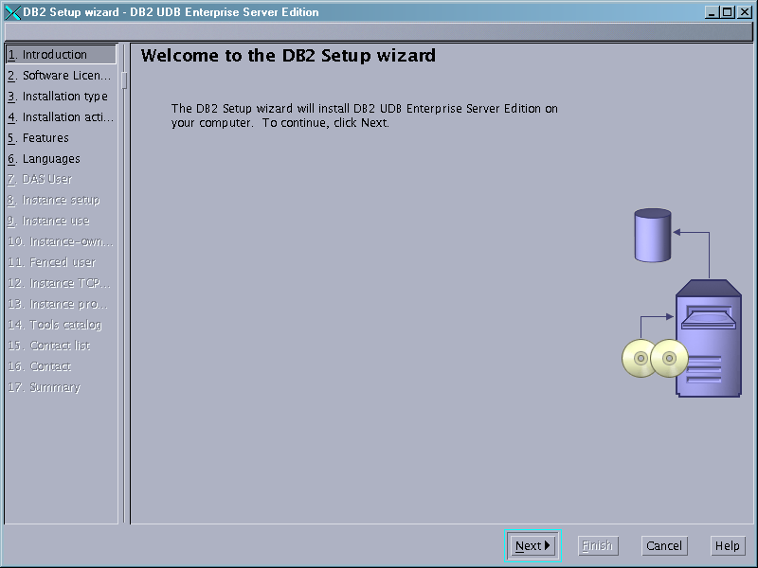 | → | 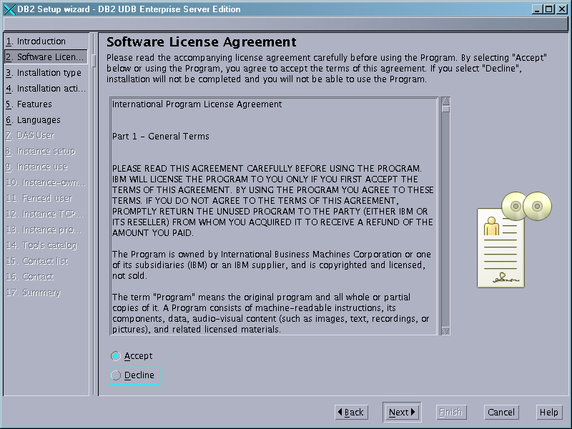

Click the typical option (unless the requester specified otherwise |  |  | Select the “Install DB2 UDB Enterprise Server option.
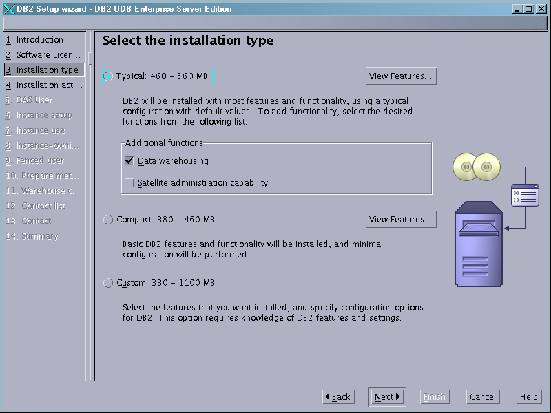 | → |  | 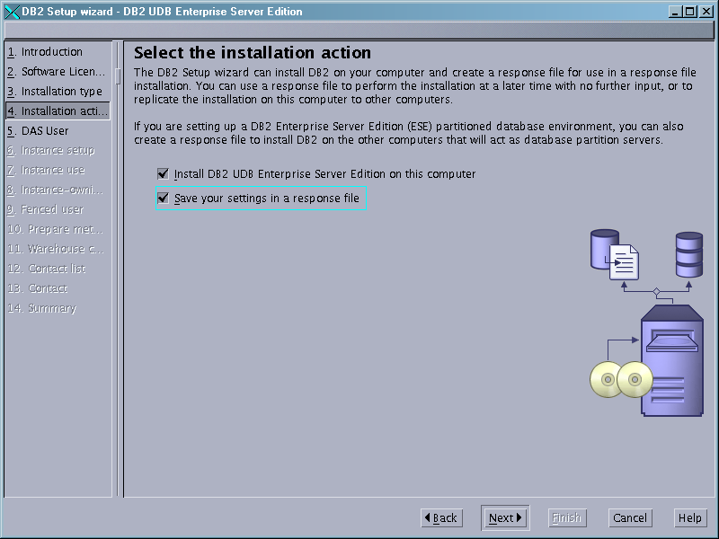
Enter the name of the admin instance (there can be only one on each box). |  |  |  | Choose “Do not create a DB2 instance if you have already created the instance ids and groups (recommended in NIS environments)
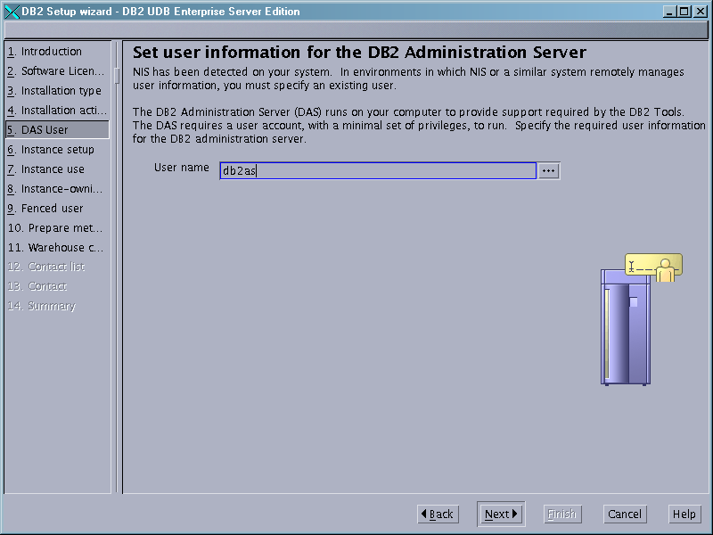 |  | → |  | 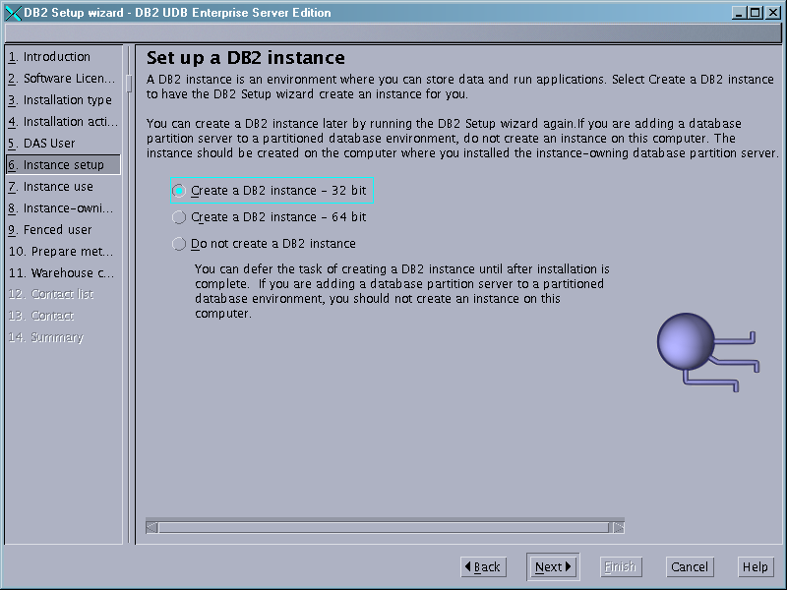

Select “Single Partition Instance”.  . |  | Enter the name of the primary (default instance).
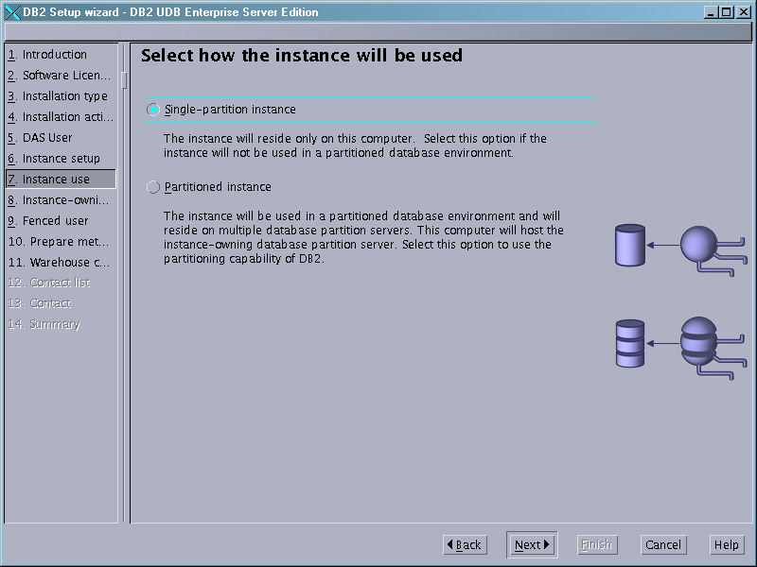 | → | 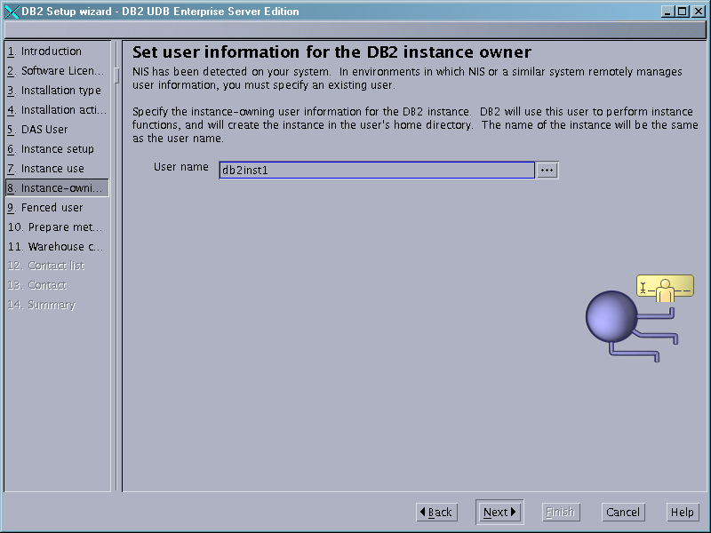

Enter the name of the fence instance id.  . |  | Choose “Do not prepare any metadata.”
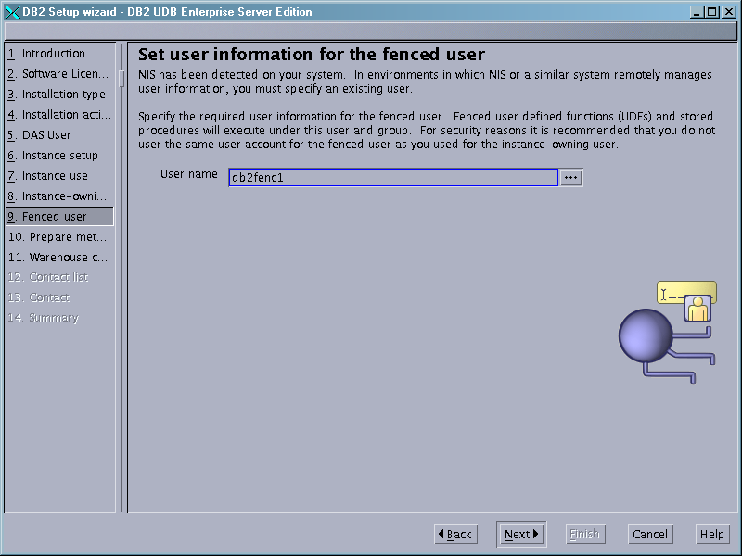 | → | 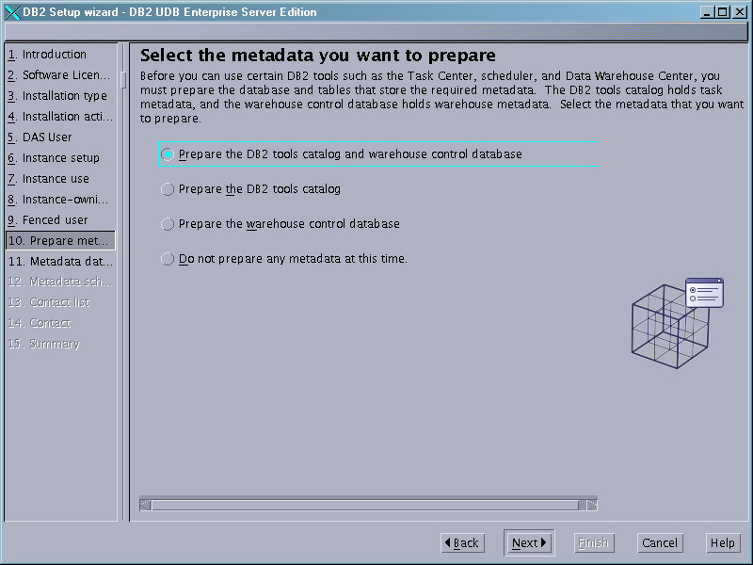

Click the first option box as above or check with the requester.
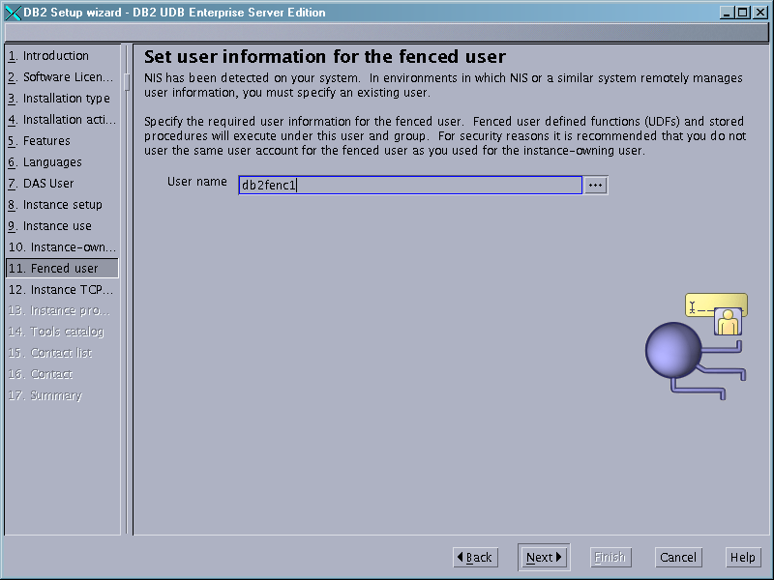

Enter name of fence id.

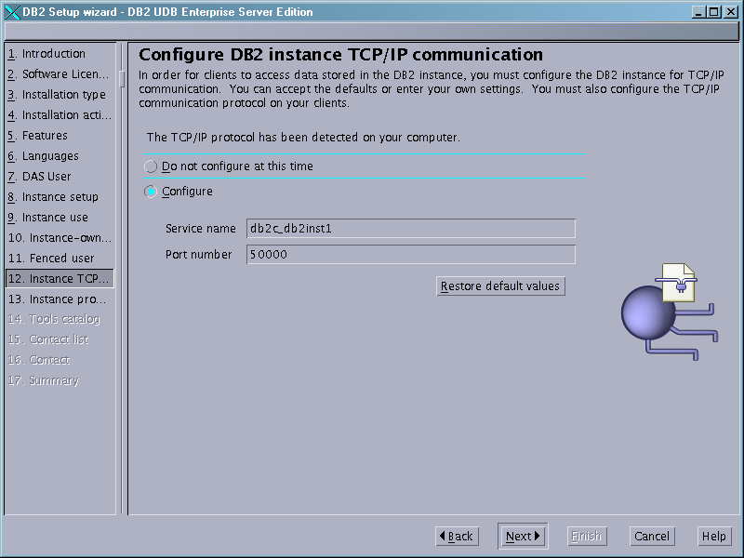

Select the configure option if you have not made any manual entries for the primary instance in the /etc/services file.

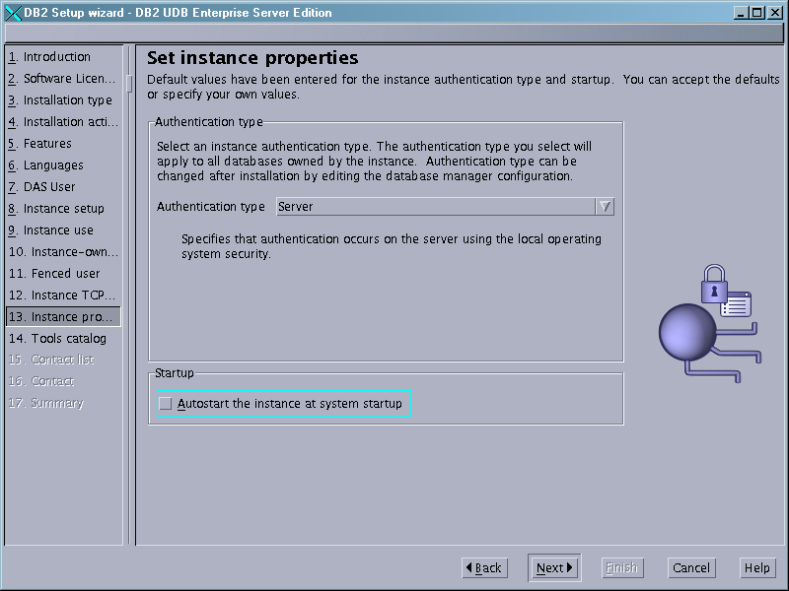

Deselect the Autostart box in “Startup”. Leave the rest as is.
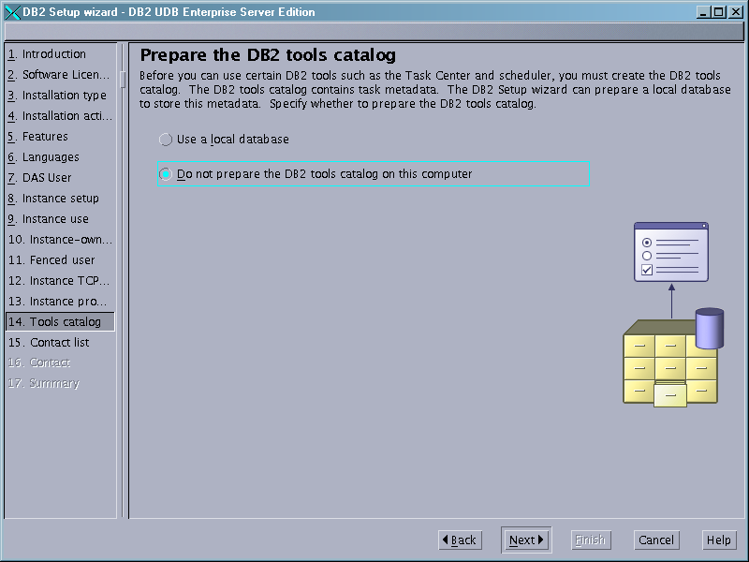

Please check with the DBA’s on this parameter or leave this for later.

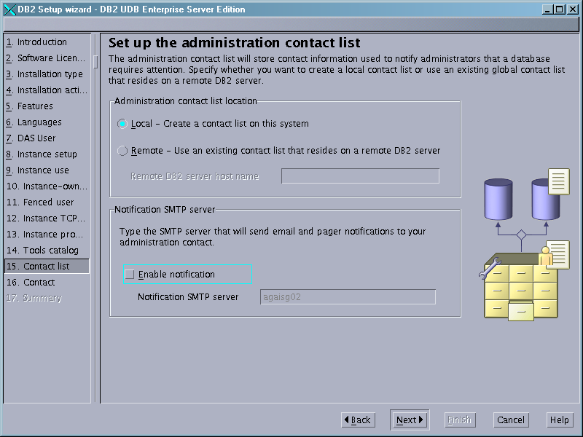

Use the default unless the requester wants it otherwise.

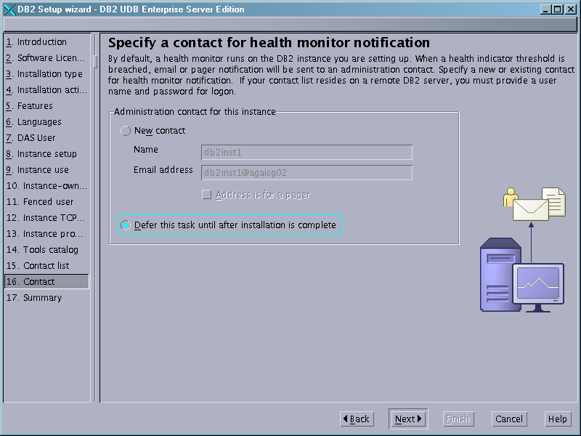

Use the defer option unless specified differently.

FixPak Info
General Notes
DB2 FixPaks
All DB2 FixPaks are cumulative hence you do not have to apply any FixPaks in between prior to the final FixPak. For operating system requirements, see this. For a list of all fixed bugs (called APARs) and support news, see http://www.ibm.com/software/data/db2/udb/support.html
If you have received special fixes from IBM(R) support, you must contact IBM support before you install any DB2 Version 8.2 FixPaks.

This helps to ensure that your system is in a consistent state and that no special fixes are lost.

Prior to DB2 Universal Database (UDB) Version 8, FixPaks functioned only as updates to installed DB2 UDB packages or file sets in one fixed location. This meant that FixPaks installation replaced existing files with updated ones, which were provided in the FixPaks. Multiple DB2 FixPak levels could not exist on a single system. Now, DB2 UDB Enterprise Server Edition (ESE) can exist at multiple fix pack levels in the same system for Linux(TM)-based and UNIX(R)-based operating systems. This feature, supported in production operating environments since Version 8.1.2, is achieved using the following two FixPak types:

Regular FixPaks Info
Are available not only for ESE, but for all supported DB2 Version 8 products for the related platforms. These can be installed directly on top of the existing installation either in the usr/opt/db2_08_01 directory on AIX(R) or the /opt/IBM/db2/V8.1 directory on other platforms. These cannot be applied on top of any installed alternate FixPaks
Alternate FixPaks (AFP) Info
Can be installed as completely new copies of DB2 UDB ESE. They are installed in a predefined location other than the location used for a regular DB2 UDB installation. There is no GUI installation procedure for alternate FixPaks. Please watch for the space usage because the alternate FixPak includes the full binary install so we need to size the install directory large enough.
All the AFP interims for the same FixPak number (such as 7a and 7b for FP7) will use the same installation path as the one used by the base AFP. For example, interim FixPak 7a uses the same installation path as alternate FixPak 7.
For example, if you want to install an AFP from a special build based on FP7c:
- If you currently have an AFP for FP7, or FP7a, or so on, you must uninstall it
- If you currently have an AFP for FP6, or FP5, or so on, you do not need to uninstall it

Default Installation Directory
On AIX: /usr/opt/db2_08_01 (regular binary and FixPaks) OR /usr/opt/db2_08_FPx (x=Alt. FixPak level)
On Unix/Linux: /opt/IBM/db2/V8.1 (regular binary & FixPaks) OR /opt/IBM/db2/V8.FPx (x=Alt. FixPak level).
FixPak Level Verification
You must have a DB2 Version 8 product installed at a lower level than your new FixPak.
AIX | lslpp -al "db2_08_01.client*" | db2_08_01.client 8.1.0.0 or later (for AIX 4.3.3)  db2_08_01.client 8.1.1.0 or later (for AIX 5)  Sample outputs for DB2 for AIX 4.3.3:  db2_08_01.client 8.1.0.0 COMMITTED ...  8.1.0.3 COMMITTED ...  8.1.0.8 COMMITTED ...  Check the largest installation signature that is  returned (8.1.0.x) to make sure it is smaller than the VRMF of the current DB2 level.  For AIX 5, the signature looks like 8.1.1.y.
Linux | rpm -qa | grep db2 | db2cliv81-8.1.0-x  db2cliv81-8.1.1-x on Linux/AMD64.  where x must be smaller than the current  level (the 4th digit in VRMF).
Solaris Operating Environment | pkginfo -l db2cliv81 | grep VERSION | VERSION: 8.1.0.x  where x must be smaller than the current  level (the 4th digit in VRMF).

Instances Verification
Run db2ilist -a command for instances and the daslist command for DAS.

HA (Cluster) Considerations
Before shutting down DB2 instance, turn off HA control of the DB2 instance. If you are an hacmp user, you must use the ha_db2stop command to stop DB2 instead of the db2stop command.
- After the upgrade is complete, turn HA control back on

The primary and DR servers need to be upgraded (to the same FixPak level at the same time). On a failover cluster, only one side needs to be upgraded.

NFS (File) Server
NFS Host: agsosg13.it.statestr.com
FixPak location: /netdist2/ DB2/<platform>/v8.1/FixPacks

Space Requirements
Directory - /opt/IBM or /usr/opt ~ 1.5 GB available
Directory - /var ~ 500MB available
FixPak Installation

DB2 V8 FixPak 15 | DB2 V8 FixPak 14 | DB2 V8.2 FixPak 1a  ( V8.1 FixPak 8a)
PTF number: U810952  Build level: s070720  Prerequisite: V8.1 GA  Signature: 8.1.1.136  Release Date:14 Aug 2007  Readme link | PTF number: U810098  Build level: s061108  Prerequisite: V8.1 GA  Signature: 8.1.1.128  Release Date:28 Nov 2006  Readme link. | PTF number: U803799  Build level: OD14081  Prerequisite: V8.1 GA  Signature: 8.1.1.82  Release Date: June 22 2005  Readme link

Determine Current DB2 level
Determine current level by doing the following:
# lslpp -al "db2_08_01.client*"
Check the largest installation signature that is returned (8.1.1.x) to make sure it is smaller than the VRMF of the current DB2 level. The current VRMF level is 8.1.1.82.
Make sure previous FixPaks have been committed as well. You should have seen if they are committed from the output.
Stop DB2 Instances (performed by DMS)
Run the following commands for each instance:
# su - iname
# . $HOME/sqllib/db2profile
# db2 force applications all
# db2 terminate
# db2stop
# db2licd -end # run at each physical node
# exit

where iname represents the instance owner name.

Stop Admin Instance (performed by DMS)
Run the following commands:
# su - aname
# . $HOME/das/dasprofile
# db2admin stop
# exit

where aname represents the DAS owner name.

Unload Unused Shared Libraries
On AIX, you should also run slibclean to unload unused shared libraries from memory before installation.
# /usr/sbin/slibclean

Stop All Other Instances Including Fault Monitor
Stop all instances that are using DB2 Version 8, including the Fault Monitor if it exists and is using DB2 Version 8. To disable the Fault Monitor Coordinator do the following (we should not use the fault monitor in State Street).
To locate where the db2fmcu command is to run from, issue the command:
# ps –ef | grep fmc
For example, on AIX the db2fmcu command is run from /usr/opt/db2_08_01/bin.
Switch to the directory indicated by the ps command.
To disable the Fault Monitor Coordinator, issue the command:
# cd /usr/opt/db2_08_01/bin
# sudo ./db2fmcu -d
To stop the Fault Monitor, issue this command as the instance owner (su - <instance name> or call your DMS contact to do this):
# sudo –t <instance name> db2fm –D
Or
# su - <instance name>
# . db2profile
# db2fm –f off

Remove the entry for the fault monitor in the /etc/inittab.
# sudo rmitab “fmc”

Clean IPC Processes
Ensure all DB2 inter-process communications (IPCs) are cleaned for the instance to be updated. As the instance owner, run the following command at each physical node:
# sudo –t <udb instance name> $HOME/sqllib/bin/ipclean
The $HOME should refer to the instance’s home directory. You can look this up from the /etc/passwd file entry for that userid. If you have trouble with this, have your DMS contact do it for you.

Install FixPak
Although SMIT is still supported, it is strongly recommended that you use the installFixPak script to install DB2 Version 8.2 FixPak 1 on AIX. If you do not want to commit the updates, you should issue the installFixPak command with the -a option (for "apply" as opposed to "commit") as follows:

This task MUST be performed as real root (not sudo). You can use the pbrun runshell “root shell” as well.
# mount hostname/netinst /mnt
# cd /mnt/DB2/aix/v8.1/FixPacks/OD_14081
# ./installFixPak -y

For FixPak 14 do this:
# mount hostname/netinst /mnt
# cd /mnt/DB2/aix/v8.1/FixPacks/FP14_U810098/fixpak.s061108
# ./installFixPak -y

Verify FixPak Installation
Determine updated level by doing the following:
# lslpp -al "db2_08_01.client*"
Ensure that you see a line similar to the one below:
8.1.x.xx COMMITTED Base Client Support

Update Default Instances
You need to be logged on as root to update the instances. For each instance, issue the command:INSTHOME/instance/db2iupdt iname, where iname represents the instance name and INSTHOME represents the installation directory appropriate to your operating system. For example, for instance u02dgw0 on dasomg00:
# cd /usr/opt/db2_08_01/instance
# sudo ./db2iupdt <instance name>
For 64 bit instances only, please run
# sudo ./db2iupdt -w 64 <instance name>
Important Note: After issuing the db2iupdt command, the Fault Monitor Coordinator maybe automatically added to /etc/inittab. Please remove this entry from the inittab file if it exists (State Street Standards).

Remove Fault Monitor Entry
Check the /etc/inittab for the fault monitor entry again. If it is there, please remove it. Remove the following lines from /etc/inittab if they exist:
rcdb2:2:once:/etc/rc.db2 > /dev/console 2>&1 # Autostart DB2 Services
fmc:234:once:/opt/IBM/db2/V8.1/bin/db2fmcd #DB2 Fault Monitor Coordinator
# sudo rmitab “rcdb2”
# sudo rmitab “fmc”
Update inittab
Add the following line “udb:3:wait:/usr/local/ccms/dba/scripts/dba_udb_start_server –a” with mkitab, to /etc/inittab if it does not already exist:

Check for the required entry.
# sudo lsitab udb
If it doesn’t exist, add it.
# sudo mkitab “udb:3:wait:/usr/local/ccms/dba/scripts/dba_udb_start_server –a”

Update Administration Instance
Run the dasupdt command, if the database administration server (DAS) instance exists and is a DB2 Version 8 DAS instance. To update the DAS instance, issue the command: INSTHOME/instance/dasupdt dasname, where dasname represents the DAS owner name and INSTHOME represents the installation directory appropriate to your operating system.
# cd /usr/opt/db2_08_01/instance
# sudo ./dasupdt <admin instance>

For more information on the db2iupdt or dasupdt commands, run db2iupdt or dasiupdt with the "-h" option.

Verify Instance Level (optional step)
Go to instance home’s INSTANCEHOME/INSTANCE/sqllib directory. For example:
Switch to instance user
# sudo –t <instance>
# cd $HOME/sqllib

Load db2 variables
# . db2profile

Determine db2 level
# db2level
You should get some response:
DB2 … and FixPak … etc.

You may also review the latest log file:
/<instance home>/<instance>/sqllib/db2dump

Notify DMS Contact of task completion.

Additional Tasks for DBA’s
Restart the instances

To restart an instance:
1. Type su <instance_name>.
2. Type the db2start command.

Repeat for each instance.

To restart the administration server, login the DAS owner ID and run the db2admin start command.
Re-binding bind files
Due to the new bind (.bnd) files that have been shipped with DB2 Version 8.1.2, you will need to bind your DB2 utilities against all your databases after installation. This step is necessary for the fixes in DB2 Version 8.1.2 to become effective. The procedure of binding, which follows, only needs to be performed once per database.
Re-binding to DB2 UDB databases
After applying fixes, you must do the following:
At a command prompt:
db2 terminate
db2 CONNECT TO <dbname>
db2 BIND <path>/@db2ubind.lst BLOCKING ALL GRANT PUBLIC
db2 BIND <path>/@db2cli.lst BLOCKING ALL GRANT PUBLIC
db2 terminate
or,
At the DB2 command line:
TERMINATE
CONNECT TO <dbname>
BIND <path>/@db2ubind.lst BLOCKING ALL GRANT PUBLIC
BIND <path>/@db2cli.lst BLOCKING ALL GRANT PUBLIC
TERMINATE
Where <dbname> represents the name of a database to which the utilities should be bound, and where <path> represents the full path name of the directory where the bind files are located, such as $HOME/sqllib/bnd where $HOME represents the home directory of the instance for the database server. db2ubind.lst and db2cli.lst contain lists of required bind files used by DB2 UDB.

