The problems we Onelogin solves
- Workday
- Zendesk
- Amazon
- Salesforce
- Google Applications

Mobile workers
Customer / Partners
Employees / contractors

SAP, Oracle, Siebl, Peoplesoft, MSOffice
Active Directory

Onelogin
#1 Ranked cloud IAM system in the current offering among all cloud IAM solutions
#1 Solution for future Development and Market plans for Cloud IAM and Technology
#1 Ranking for customer satisfaction

Onelogin
- AD configuration / integration
- Access Management Policy Administration
- End user self service
  - Realtime Directory Integration
  - Cloud Directory
  - Access Management
  - Secured Single Sign-on
  - Multifactor Authentication
  - Self-Serve Password Reset
  - Realtime User Provisioning
  - Centralized Reporting
  - Hybrid Enterprise Toolset
  - Developer Integration Tools
  - Realtime User sync with Active Directory
  - Authentication takes place behind the firewall (no AD credentials stored in the cloud)
  - Role based access
  - Flexile provisioning engine
  - Optional on premise provisioning with SCIM proxy agent.

Provisioning – Active Directory

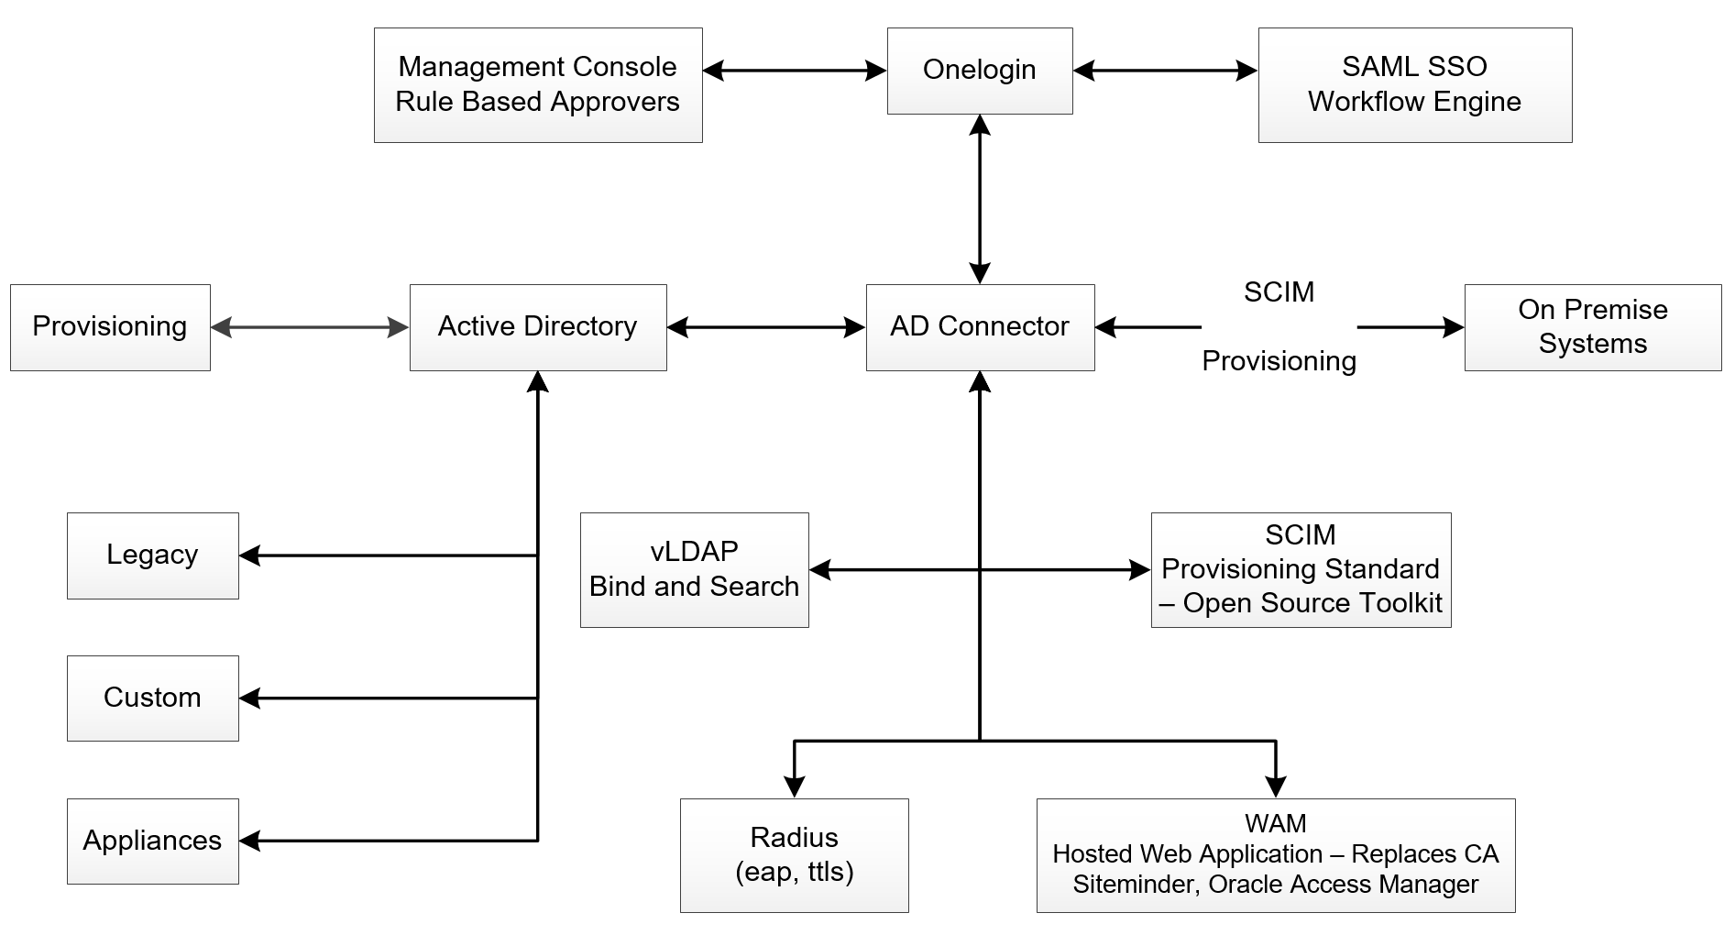

- One login increases security, Readiness IT Costs and improve Productivity

- Securely add Applications at the speed of business

- Enforce Security for Applications and Devices

- Minimize Identity Management Spend

- Increase IT Team productivity and Enterprise Security

- Engage employees to enforce Policy and work more productivity

