Professional Services

Design Document

Prepared for
Corporate

Table of Contents

1 Overview 3
1.1 Current Landscape 3
1.2 Proposed Landscape 3
1.3 ARM Interfaces 3
1.3.1 Overview 3
2 Infrastructure 3
2.1 Current 3
2.1 Proposed Revisions 3
2.2 Details 3
3 Solution Design 3
3.1 ARM-WF1 Account Change/Add by Requestor 3
3.1.1 Process Flow 3
3.1.2 Business Process Overview 3
3.1.3 Workflow Pre-Processing 3
3.1.4 Workflow Post-Processing 3
3.1.5 Notifications 3
3.1.6 Workflow Initialization 3
3.1.7 Access Request Manager Roles Used 3
3.1.8 Technical Configuration 3
3.2 ARM-WF2 Approval Process 3
3.2.1 Business Process Overview 3
3.2.2 Workflow Pre-Processing 3
3.2.3 Workflow Post-Processing 3
3.2.4 Notifications 3
3.2.5 Workflow Initialization 3
3.2.6 Access Request Manager Roles Used 3
3.2.7 Technical Configuration 3
3.3 ARM-WF3 Termination Process 3
3.3.1 Process Flow 3
3.3.2 Business Process Overview 3
3.3.3 Workflow Pre-Processing 3
3.3.4 Workflow Post-Processing 3
3.3.5 Notifications 3
3.3.6 Workflow Initialization 3
3.3.7 Access Request Manager Roles Used 3
3.3.8 Technical Configuration 3
3.4 ARM Configuration 3
3.4.1 Access Catalog 3
3.4.2 ARM Database 3
3.4.3 Courion Database 3
3.4.4 Dynamic Communities 3
3.4.5 Entitlements 3
3.4.6 Courion Services 3
3.5 AC-WF1 LightsOut_AccessRequest 3
3.5.1 Business Process Overview 3
3.5.2 Workflow Initialization 3
3.5.3 Workflow Post-Processing 3
3.5.4 Notifications 3
3.6 AC-WF2 LightsOut_Termination 3
3.6.1 Business Process Overview 3
3.6.2 Workflow Initialization 3
3.6.3 Workflow Post-Processing 3
3.6.4 Notifications 3
3.7 AC-WF3 Add New Non-Employee 3
3.7.1 Business Process Overview 3
3.7.2 Workflow Initialization 3
3.7.3 Technical Configuration 3
3.8 AC-WF4 Change Non-Employee Demographic Information 3
3.8.1 Business Process Overview 3
3.8.2 Workflow Initialization 3
3.8.3 Technical Configuration 3
3.9 AC-WF5 AD Username Lookup 3
3.9.1 Business Process Overview 3
3.10 AC-WF5 Access Level Lookup 3
3.10.1 Business Process Overview 3
4 IdentityMapping 3
5 Database Schema 3
5.1 Schema Description 3
5.2 Database Merging 3
6 Data Contracts 3
6.1 FIM 3
6.1.1 Overview 3
6.1.2 Table/View Schemas 3
7 Future Items 3
7.1 Authentication 3
7.2 Delegations 3
7.3 Emergency Terminations 3

Overview

Current Landscape

Proposed Landscape

ARM Interfaces

Overview

Infrastructure

Current
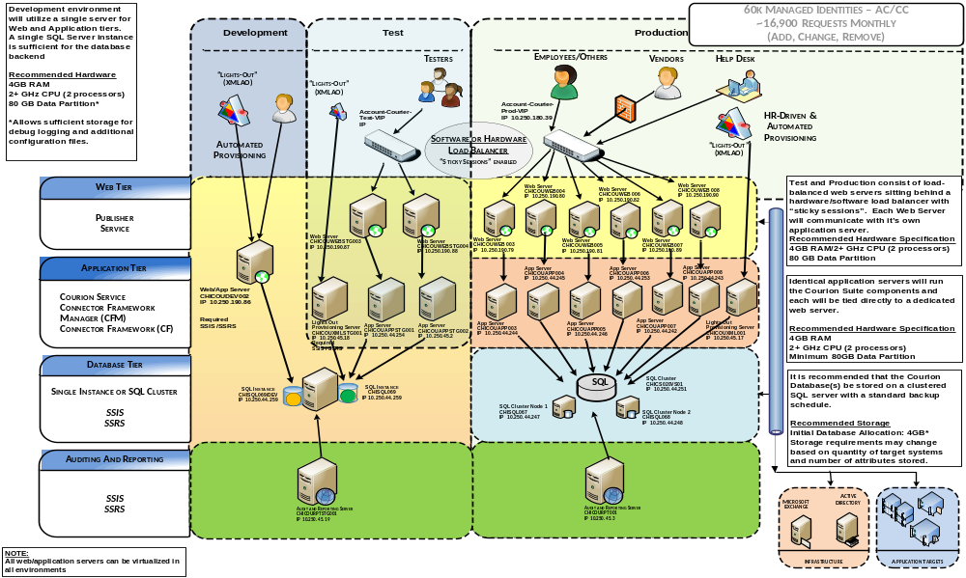

Proposed Revisions
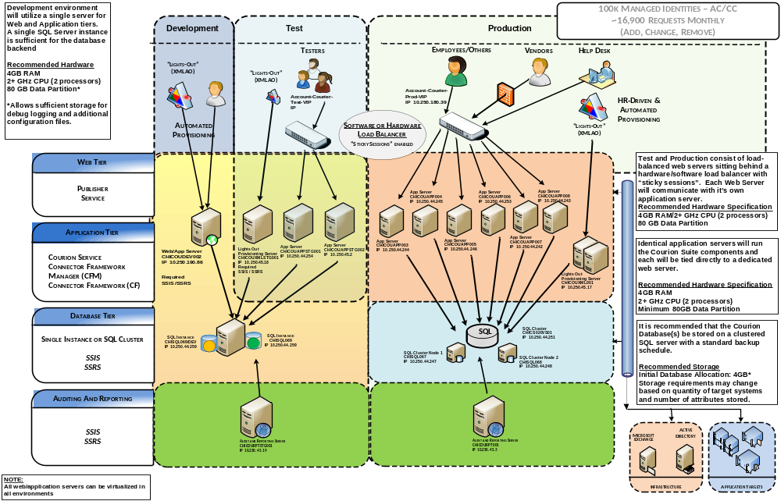

Details
In the above proposed revised infrastructure diagram, we have factored in updated requirements based on ARM vs. Provisioning platform and weighed in an anticipated increased user population size (60k to 100k) while balancing this against changes in original assumptions pertaining to expected request loads (original estimates factored in self-service requests vs. proposed solution limited to Supervisors) and derived the proposed diagram.
ARM deployments gain a negligible performance increase by separating the web and app tiers into separate servers, so removal of these redundant web server tier(s) is recommended.
Addition attention should also be given to the Lights-Out (XMLAO) provisioning servers. We propose a hot backup to address single point of failure concerns. Capabilities and resources to be determined

Solution Design

ARM-WF1 Account Change/Add by Requestor
This workflow will leverage the Access Request Manager solution to provide an interface for users to request additional access for existing users.

Process Flow

Business Process Overview
Users of the Courion Access Assurance Portal will be able to access the workflow through a menu option which will be shown to Supervisors. Accessing this menu item will bring the user (provisioner) to the Access Request Manager User Detail screen.
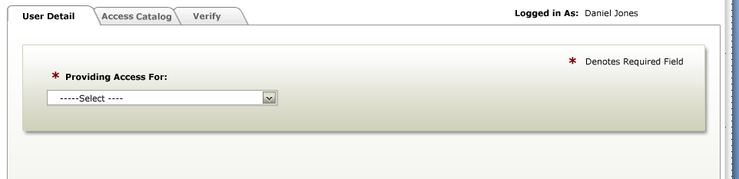
The provisioner will begin by selecting who they are requesting access for (provisionee). To begin, the provisioner will choose whether they want to request access for an (*Providing Access For:” Drop-down):
- Employee
- Non-Employee

Once the provisioner chooses a user type, they will see the search screen.
* Note that the Acting As drop-down is reserved for delegation. This will be available in a subsequent release (see Future Items, Section 7)

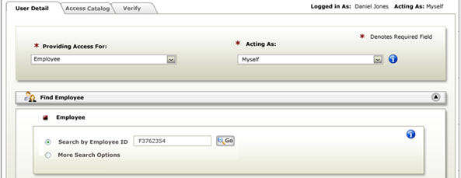
From the search screen, the provisioner may search for a unique provisionee based on their Email Address or return a list of matched provisionees by providing through the “More Search” Option:
- First Name
- Last Name
- Department
- Phone Number
- Facility (Location)

Provisionees who have a matching user type and match the search criteria will appear in the search results screen (columns referenced in GlobalConfigValue: MultiUserSearchResultFields)

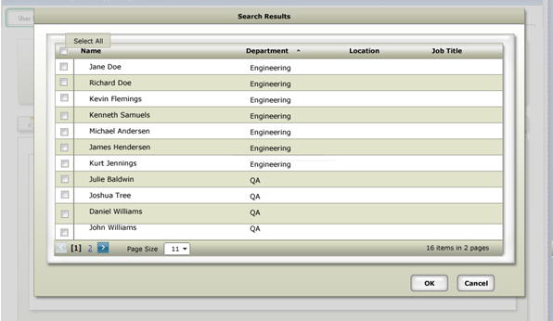
As users are found they can be added individually to the list of provisionees for the access request. The provisionee community will appear in the selected users section of the Access Request Manager User Details screen (columns referenced in GlobalConfigValue: MultiUserSearchResultFields)
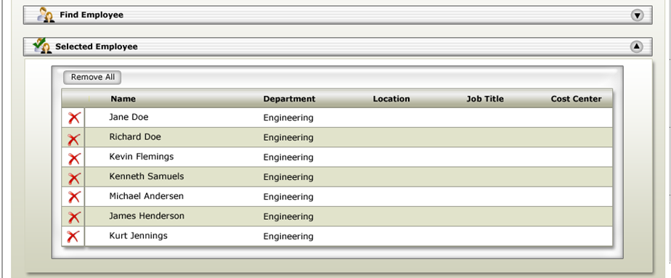

Once the provisionee community has been defined, the provisioner can then proceed to the Access Request Manager Access Catalog screen. On the Access Catalog screen the provisioner will then be able to choose how they would like to view the list of available access levels, either by Application where the access levels are grouped together by their parent application or Ad Hoc where the list will display all available access levels regardless of the application. Drop-Down options are as follows:
- Access - Clinical Applications
- Access - Non-Clinical Applications
- Software – Business Applications
- Software – Communication
- Software – Other
- Facility – Badge Access
- Facility – Office Setup
- Hardware – PC/Laptop
- Hardware – Telephony
- Hardware - Wireless Device
- Remote / VPN / Internet Access
- Misc. / Other
- View All (Ad-Hoc)

To guide the provisioner through the process of locating desired access levels in the Access Catalog, a search link may be embedded on the page. This link will direct the provisioner to a custom webpage/pdf/provisioning workflow that will allow the provisioner to search for an access level by name. Once the access level is located, the full Access Catalog path will be displayed (i.e. Filter By Option > Application > Access Level).

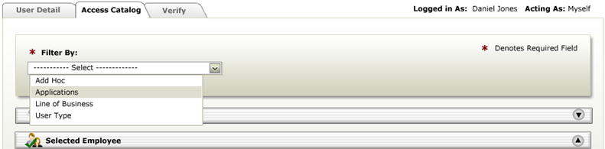

Based on how the provisioner has chosen to filter access they will see a list of access levels which can be added to the provisionee community and one or more of the access levels can be selected. There will be no restriction placed on the available applications or access levels that are available to the provisioner. Control of what is provisioned will be left up to the provisioner and access approvers to filter out invalid requests.
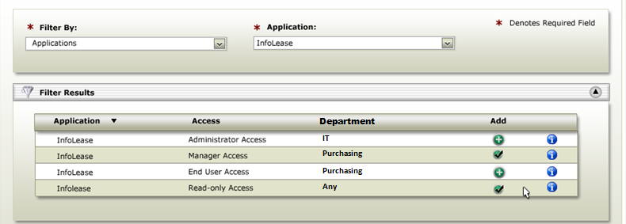
Selecting an access level for a user can optionally result in a prompt for more information, depending on how the access level has been configured.
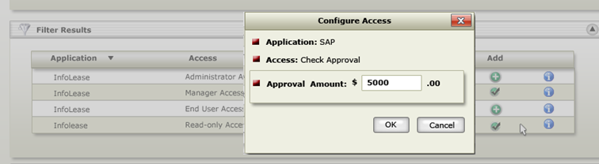

Once all of the desired access levels have been added to the request, the provisioner can click next to proceed to the Access Request Manager Verify screen.
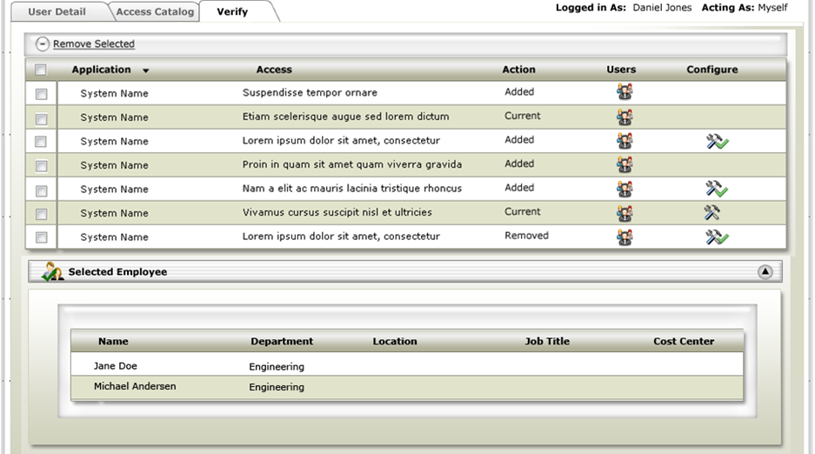
The Access Request Manager Verify screen allows the provisioner the ability to review the provisionee community and the access levels which have been selected for the request. For user access which already exists for a member of the provisionee community, an access level will be displayed, which will allow for a request to be generated to remove that access level from a provisionee.
Once the details of the request have been confirmed by the provisionee, the request can be submitted for approval.

Workflow Pre-Processing
In order for a user to be included in an Access Request through ARM-WF1, the user must already exist within the Courion Profile table. Any access levels which are to be requested for the provisionee community must have been pre-configured by administrators.

Workflow Post-Processing
After a request is submitted, a parent request record will be generated in the Courion Database with sub-request records for each of the access levels. If any of the sub-requests require approval, request approval entries will be added to the Courion Database and notification will be sent to the first approver for the request. For all other sub-requests, a lights out workflow will be triggered to generate the Remedy Incidents.
Any Remedy Incidents that are generated will be tracked in the Courion Database to allow reference for incident number and status through ARM.

Notifications
Notifications will be sent to the first approver for each sub request.

Workflow Initialization
Provisioners will access this workflow by logging in to the Courion Access Assurance Portal available on InsideCHI web site and selecting the Access Request menu item.

Access Request Manager Roles Used
Access Request Manager Roles define the different communities of users who interact with the Access Request Manager application. The following roles will be used in the deployment of ARM-WF1 Account Change/Add by Requestor:
- Business Supervisor
  - This role represents the logged in user who is accessing the workflow. This role can request access for direct reports, create new non-employees, and can request any access level

Technical Configuration
This section covers the various configuration changes which will be made to the Access Request Manager application for the purposes of supporting ARM-WF1 Account Change/Add by Requestor.

Custom Macros
- Is BusinessSupervisor
  - This macro will be created and will check for the presence of the logged in user ProfileUID in the SupervisorID column in the Profile table. This macro will be used by the Business Supervisors dynamic community definition to determine if a user is a Business Supervisor.
- Get LoggedInUser Role
  - This macro will be altered to always return a value of ‘Business Manger’ when the logged in user has at least 1 occurrence of ProfileUID in the SupervisorID field in the Profile table.
- Get AccessCatalog Default Restriction
  - This macro will be altered to return all Access Levels
- SQL.GetLoggedInUserProfileUID
  - This macro will be created to identify the logged in user’s Profile UID (Employee ID) based on their Active Directory account name and domain.

Global Config Values
- SingleUserSearchKey
  - This entry will be modified to point to a column named “email” and use a label of “Search by Email Address”
- SingleUserSearchResultFields
  - This entry will be modified to display the following fields:
    - First Name
    - Last Name
    - Department
    - Phone Number
    - Facility (Location)
    - E-mail address
- MultiUserSearchResultFields
  - This entry will be modified to display the following fields:
    - First Name
    - Last Name
    - Department
    - Phone Number
    - Facility (Location)
    - E-mail address
- AccessCatalogFilters
  - This entry will be modified to show the following Access Catalog filters:
    - Access - Clinical Applications
    - Access - Non-Clinical Applications
    - Software – Business Applications
    - Software – Communication
    - Software – Other
    - Facility – Badge Access
    - Facility – Office Setup
    - Hardware – PC/Laptop
    - Hardware – Telephony
    - Hardware - Wireless Device
    - Remote / VPN / Internet Access
    - Misc. / Other
    - View All (Ad-Hoc)
- UserSearchOptions
  - This entry will be modified to remove the Add New option. Adding new non-employees will be handled through a Provisioning workflow which will be linked to from this page as well as a menu item.

Customizations API
The following changes will need to be handled by the Customizations API:
- All access levels that require approval will be routed through the approval model. Any access levels that do not require approval will automatically generate a separate Remedy Incident. After an access level is fully approved a separate Remedy Incident will be generated.

ARM-WF2 Approval Process

Business Process Overview
Users of the Courion Access Assurance Portal will be able to access the approval workflow through a menu option which will be shown to all users who are found in the Access Approvers community. Accessing this menu item will bring the user (approver) to the Access Request Manager Approval Queue screen.
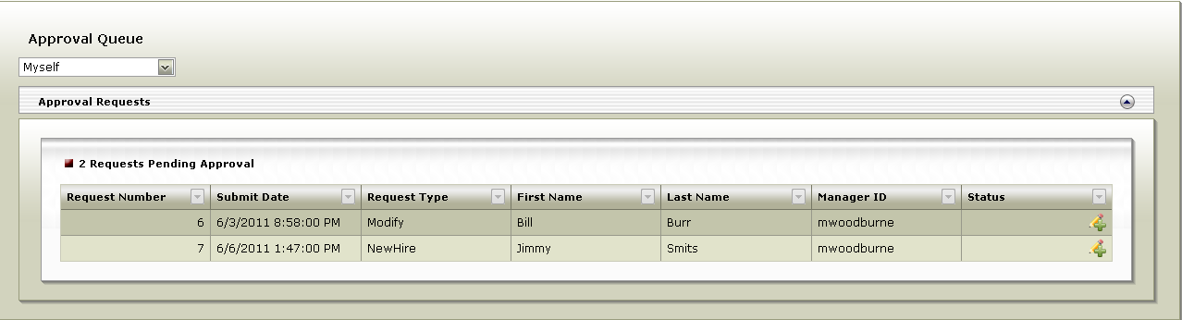
From the Approval Queue screen the approver will be able to select individual requests that they would like to view the details of. By selecting a request from the Approval Queue the approver will see a pop-up which contains all of the details of the request.
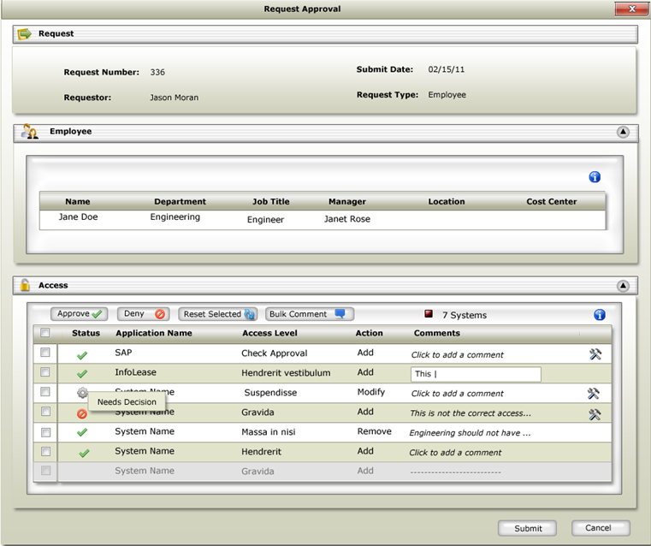
The Request Detail pop-up provides the approver with all of the information needed to review the request and make a decision on the individual access levels requested. The approver will see information about who requested the access, who the requested access is for, and what access has been requested. For each access level requested, the approver can make the decision to approve or deny the request. For each decision made, the decision applies to all of the users who are included in the request. In the event that the approver makes the decision to deny an access request, the approver will be required to provide a comment stating why the request was rejected.
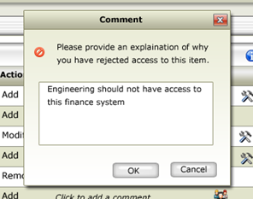
Once all of the access level requests are completed the approver will submit the decisions for processing.
All approved access requests will be submitted to a Courion workflow which will generate tickets to the Remedy ticketing system.

Workflow Pre-Processing
In order for a request to be approved by the approver they must be specified as the approver in the AccessApprovers table. Users will not be able to access the Approve Requests section of the Access Request Manager unless they have requests within the AccessApprovers table which identify them as the approver.

Workflow Post-Processing
After a request has been approved, the next approval step will become available and a notification will be sent to the approver responsible. If the request is fully approved, a Lights Out Workflow will generate a Remedy Incident.
Any Remedy Incidents that are generated will be tracked in the Courion Database to allow reference for incident number and status through ARM.

Notifications
If the request is denied, a notification will be sent to the requestor and no additional approvals will be allowed.
For each approval that becomes available as the result of an approval, a notification will be sent to the approver responsible.

Workflow Initialization
Provisioners will access this workflow by logging in to the Courion Access Assurance Portal and selecting the Approve Requests menu item.

Access Request Manager Roles Used
Access Request Manager Roles define the different communities of users who interact with the Access Request Manager application. The concept of Access Request Manager roles does not apply to the approval process.

Technical Configuration

Custom Macros
- Is AccessApprover
  - This macro will be created and will check for the presence of the logged in user in the AccessApprovers table. This macro will be used by the Access Approvers dynamic community definition to determine if a user is an access approver.

Global Config Values
There are no current requirements for modifying any entries in the GlobalConfigValues table. Some changes may be made to expose different fields for Profile information, but there are no requirements at this time.

Customizations API
The following changes will need to be handled by the Customizations API:
- Modification of approval lookup to translate values between AD username and ProfileUID

ARM-WF3 Termination Process

Process Flow

Business Process Overview
Users of the Courion Access Assurance Portal will be able to access the termination workflow through a menu option which will be shown to all users who are found in the Business Supervisors community. Accessing this menu item will bring the user (provisioner) to the Access Request Manager Termination screen.
From the Supervisor Termination screen the provisioner will be able to select the user (provisionee) that they would like to disable. The provisioner will enter the AD Username of the provisionee they would like to disable and click the validate button. The demographic details of the provisionee will be displayed as well as all of the access levels that the user has.
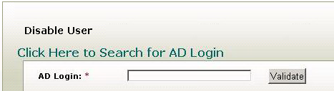
If the provisioner does not know the active directory account of the user they wish to terminate, they will click on an embedded link that will direct them to a provisioning workflow where they can search for the AD Username by the user’s First Name, Last Name, and Facility (Location).
The provisioner can optionally provide comments in the comments box and will need to verify that they recognize that by submitting the form, all of the access the user currently has, will be removed.
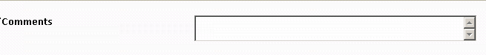

Workflow Pre-Processing
In order for a user to access the Supervisor Termination page, they will need to have at least 1 ProfileUID in the SupervisorID field in the Profile table.

Workflow Post-Processing
Once a termination has been submitted, a Lights Out workflow will be triggered to immediately disable the user’s Active Directory account, move them to a disabled users OU (specific to the domain) and to generate a Remedy Incident for the removal of all other access. In addition, a notification will be sent to HR and to the provisioner informing them of the termination.
Any Remedy Incidents that are generated will be tracked in the Courion Database to allow reference for incident number and status through ARM.

Notifications
When a termination request is submitted a notification will be sent to HR and to the provisioner informing them of the termination.

Workflow Initialization
Provisioners will access this workflow by logging in to the Courion Access Assurance Portal and selecting the Supervisor Termination menu item.

Access Request Manager Roles Used
Access Request Manager Roles define the different communities of users who interact with the Access Request Manager application. The following roles will be used in the deployment of ARM-WF3 Account Change/Add by Requestor:
- Business Supervisor
  - This role represents the logged in user who is accessing the workflow. This role can request access for direct reports, create new non-employees, and can request any access level

Technical Configuration

Custom Macros
- Is BusinessSupervisor
  - This macro will be created and will check for the presence of the logged in user ProfileUID in the SupervisorID column in the Profile table. This macro will be used by the Business Supervisors dynamic community definition to determine if a user is a Business Supervisor.

Global Config Values
There are no current values in the GlobalConfigValues table to modify the Termination form.

Customizations API
There are no customizations that can be made to the Termination workflow through the Customizations API.

ARM Configuration

Access Catalog

Bulk Load
A spreadsheet containing all of the Applications and Access Levels will be maintained by CHI. This spreadsheet will be used by an SSIS package to load all applications and access levels into the access catalog. This SSIS package will only be run once and will not handle defining access attributes or access approvers

Day-to-day Maintenance
The daily maintenance of the access catalog will be handled by the ARM Administrators. This will include, but is not limited to: updating access attributes, access approvers, applications, and access levels.

ARM Database
A new database will need to be created to store the data associated with ARM. This is due to the naming conflicts which exist between tables in the Courion database and tables in the ARM database.

Profile
The Profile table within the ARM database will need to be updated to handle the changes in field sizes between the Courion Profile table and the ARM Profile table. If it is determined to be required, the table will also need to add additional fields in order to better line up with what is currently defined in the Courion Profile table.

Staging_FIM
This table will be inserted into the ARM database to use to interact with FIM. Please see Data Contracts, Section 6, for the details.

Staging_Courion
This table will be inserted into the ARM database for FIM to push information back to Courion to use for IdentityMapping

Courion Database

PortalMenu
The PortalMenu table will need to be modified in order to accommodate the new menu entries available within ARM. The default script can be used to populate the PortalMenu table, and the following entries will be added/removed:
- Remove all entries for Basic Users – There will be no basic user access into the portal. The authenticated user will need to meet requirements for one or more of the communities to see any menu items.
- Remove Role/Access Mapping – This entry will be removed as this functionality will not be leveraged by CHI
- Add New Non-Employee – This entry will be added and linked to a Provisioning workflow for the creation on new non-employees.
- Add Change Non-Employee Demographic Information – This entry will be added and linked to a Provisioning workflow to allow supervisors to change the demographic information of employees and non-employees.

Dynamic Communities
The following dynamic communities will be defined (either created or modified) in order to control menu entries for authenticated users:

ARM Admins
This community represents the users who will be able to perform administrative tasks within ARM. This will grant the user the ability to define applications and access levels, modify configurations and picklist values, and view all requests submitted via ARM.
This community will be defined by the Courion ARM Admins group membership within Active Directory.

Business Supervisors
This community represents the users who will be able to initiate access requests and terminations within ARM.
This community will be defined by the presence of the authenticated user’s ProfileUID in at least 1 SupervisorID field in the Profile table.

Access Approvers
This community represents the users who will be able to perform approvals of requests within ARM.
This community will be defined by the presence of the user within the AccessApprovers table.

Entitlements
No changes will need to be made to the Entitlements for the Access Request application.

Courion Services
Two services will be installed on the Lights Out server(s):

Courion Notification Service
The notification service will run on a scheduled interval (adjusted through the app.config file in the Courion Service directory) and will read the Notifications table in the ARM database. This table includes records for all notifications that need to be sent out. When the service finds a notification that has not been sent, it sends it to an Exchange server that handles the sending of the email. After the notification has been sent, the service updates the record with a sent flag and a date time stamp.

Courion Request Service
The request service will run on a scheduled interval (adjusted through the app.config file in the Courion Service directory) and will read the Request table in the ARM database. This table includes records for all requests that are available for processing. Based on the record type, the request service will decide which Lights Out workflow to submit the request to. The handling of the request after that time will be controlled by the Lights Out workflow.

Service Configuration
In the Courion Service folder, there are app.config files for each of the services. Each app.config file contains the follow configuration options:
- Polling Interval
- Debug Logging Flag – 1 is on; 0 is off. All logs will be written to the Windows Applications Event Log.
- Server – for request service this refers to the Lights Out server name; for notification service this refers to the Exchange server.

AC-WF1 LightsOut_AccessRequest

Business Process Overview
The Courion Request Service running on the Lights Out server will examine the sub request table for any available requests. This lights out workflow will be responsible for the generation of Remedy Incidents based on the details of the available sub request(s).

Workflow Initialization
This provisioning workflow will be triggered in one of the two scenarios:
- An Access Request is submitted from ARM-WF1
- A request becomes fully approved from ARM-WF2

Workflow Post-Processing
When a Remedy Incident is entered, the Incident number and initial status will be updated in the Courion database for the related sub request. Additionally, a notification will be sent to the requestor with the details of the Remedy Incident.

Notifications
After the workflow completes the action a notification will be sent to the requestor with the details of the Remedy Incident.

AC-WF2 LightsOut_Termination

Business Process Overview
The Courion Request Service running on the Lights Out server will examine the sub request table for any available termination requests. This lights out workflow will be responsible for disabling all active directory accounts and moving the accounts into a disabled users OU (specific to the domain) for the user in the sub request as well as the generation of Remedy Incidents based on the details of the available sub request(s).

Workflow Initialization
This provisioning workflow will be triggered when a termination request is submitted from ARM-WF3

Workflow Post-Processing
When a Remedy Incident is entered, the Incident number and initial status will be updated in the Courion database for the related sub request. Additionally, a notification will be sent to HR and the requestor with the details of the Active Directory account disables and Remedy Incident details.

Notifications
Once the workflow completes a notification will be sent to HR and the requestor with the details of the Active Directory account disables and Remedy Incident details.

AC-WF3 Add New Non-Employee

Business Process Overview
Users of the Courion Access Assurance Portal will be able to access the add new non-employee workflow through a menu option which will be shown to all users who are found in the Business Supervisors community. Accessing this menu item will bring the user (provisioner) to the Add New Non-Employee provisioning workflow.
The first step in the workflow is to prompt the provisioner for their Active Directory credentials (samAccountName and Password).
Once the provisioner has authenticated into the workflow, they will be presented with a list of user types including:
- Contractor/Consultant
- Service
- Student
- Telecommuter
- Temporary
- Vendor
- Volunteer

The provisioner will only be able to select one of the user types in the list above.
Once the user type has been selected and the form submitted, the provisioner will be presented with a form to collect the basic demographic information about the user including (* required field):
- First Name*
- M.I.*
- Last Name*
- Nickname
- Job Title*
- Department*
- Section
- Unit
- Floor
- Cube/Space Location
- Role*
- Function*
- MBO/Campus*
- Facility Location*
- Building
- Mail Stop
- E-mail Address
- Phone & Fax Number
- Work Phone
- Fax

Based on the selection of the user type, an additional form will be presented to complete the details of the new non-employee as follows:
Contractor/Consultant
- Contracting Company/Agency Name
- Non-CHI e-mail address

Service/Vendor
- Service Account
- Vendor Account
- Detailed Business Need/Purpose
- Responsible System Analyst
- System Analyst Mgr/Project Mgr
- Responsible Server Analyst
- System Name
- Detailed Access Rights

Student
- School Name
- Non-CHI e-mail address

Telecommuter/Temporary
- Non-CHI e-mail address

After this form is submitted, a record will be added in the Profile for the New Non-Employee and a request will be submitted to FIM to create all necessary accounts.

Workflow Initialization
Provisioners will access this workflow by logging in to the Courion Access Assurance Portal and selecting the Add New Non-Employee menu item.

Technical Configuration

Action
The create action will be the only available action in the workflow.

Resource Community
The resource community will be a model user in the Profile/IdentityMap table

Initial Profile
The initial profile attributes XML file will be altered to expose the attributes discussed in the overview (* required field):
- First Name*
- M.I.*
- Last Name*
- Nickname
- Job Title*
- Department*
- Section
- Unit
- Floor
- Cube/Space Location
- Role*
- Function*
- MBO/Campus*
- Facility Location*
- Building
- Mail Stop
- E-mail Address
- Phone & Fax Number
- Work Phone
- Fax

Unique Resource Data
Each user type (IdentityMap target) will be a separate Workflow Only Event (WFE) target that will expose the attributes listed in the Overview above:
Contractor/Consultant
- Contracting Company/Agency Name
- Non-CHI e-mail address

Service/Vendor
- Service Account
- Vendor Account
- Detailed Business Need/Purpose
- Responsible System Analyst
- System Analyst Mgr/Project Mgr
- Responsible Server Analyst
- System Name
- Detailed Access Rights

Student
- School Name
- Non-CHI e-mail address

Telecommuter/Temporary
- Non-CHI e-mail address

Triggers
On Action Success the IdentityMap entry that was added as a result of the create action will be removed.
On Action Success an entry will be added to the STAGING_FIM table to allow FIM to generate all necessary accounts.
On Action Success for each of the WFE targets, an update SQL statement will be executed against the profile entry to update the user type.

Notifications
When FIM has created all of the necessary accounts, it will send the information back to Courion. Courion will then take the details of the accounts that were created and send a notification to the supervisor

AC-WF4 Change Non-Employee Demographic Information

Business Process Overview
Users of the Courion Access Assurance Portal will be able to access the change non-employee demographic information workflow through a menu option which will be shown to all users who are found in the Business Supervisors community. Accessing this menu item will bring the user (provisioner) to the Change Non-Employee Demographic Information provisioning workflow.
The first step in the workflow is to prompt the provisioner for their Active Directory credentials (samAccountName and Password).
After the provisioner has authenticated into the Workflow, they will be presented with a list of their non-employee direct reports. From this screen the provisioner will be able to select one non-employee to change demographic information about.
Once the non-employee has been selected the following fields will be presented to the provisioner for change (* required field):
- First Name*
- M.I.*
- Last Name*
- Nickname
- Job Title*
- Department*
- Section
- Unit
- Floor
- Cube/Space Location
- Role*
- Function*
- MBO/Campus*
- Facility Location*
- Building
- Mail Stop
- E-mail Address
- Phone & Fax Number
- Work Phone
- Fax

Workflow Initialization
Provisioners will access this workflow by logging in to the Courion Access Assurance Portal and selecting the Change Non-Employee Demographic Information menu item.

Technical Configuration

Action
The change action will be the only available action in the workflow.

Provisionee Community
The provisionee community will be a single user selected from a list of non-employee direct reports of the provisioner.

IdentityMap
The profile IdentityMap entry will be automatically selected.

Unique Resource Data
A list of demographic information about the non-employee will be displayed as the unique resource data for the profile target. The only target will be the profile table in the Courion database.

Triggers
On Action Success the entry for the user in the STAGING_FIM table will be updated to trigger the FIM change action.

AC-WF5 AD Username Lookup

Business Process Overview
This workflow will be accessed from a link embedded in the Supervisor Termination page within the Courion Access Assurance Portal.
This workflow will be used to allow a supervisor to search for his/her direct reports’ Active Directory Usernames.
When the user launches the workflow, they will authenticate with their Active Directory credentials (CHI samAccountName and Password).
The authenticated user will then be presented with a form where they can enter the desired user’s First Name, Last Name and Facility (Location).
Based on the information entered a record will be returned with the user’s Active Directory Username. There will be instructions on this page to guide the authenticated user to copy and paste the returned Username into the Termination form.

AC-WF5 Access Level Lookup

Business Process Overview
This workflow will be accessed from a link embedded in the Access Catalog page within the Courion Access Assurance Portal - Access Request page.
This workflow will be used to allow a supervisor to search for Access Levels within the Access Catalog.
When the user launches the workflow, they will authenticate with their Active Directory credentials (CHI samAccountName and Password).
The authenticated user will then be presented with a form where they can enter the desired Application Name and Access Level name.
Based on the information entered, a record will be returned with the location of the access level in the Access Catalog (i.e. Filter by Option, Application Name, Access Level).

IdentityMapping
All Profile and IdentityMapping logic will be pulled out of ILM/FIM and warehoused within the ARM solution. Presently, ILM/FIM is managing Courion Profile table data as well as Courion IdentityMap; going forward, Courion will manage these tables/processes through standard services offerings.
A one-time snapshot will be taken of both Profile and IdentityMap tables prior to severing the data mapping link from ILM/FIM to Courion. This snapshot data will then be cleaned to preserve meaningful user demographic and mapping data as a starting point before updated process come online. Once the snapshot data is cleansed, Profile data for employees will be managed by the Lawson to Courion data contract and Profile data for Non-Employees will be maintained by Courion manual workflows.
IdentityMapping rules will be matched to ProfileUID with data sources currently coming from FIM for ActiveDirectory data. A data cleanup effort is acknowledged on the part of CHI to allow for reliable matching results. FIM will maintain the STAGING_IdentityMap_FIM table for source data within the Courion IdentityMapping process.

Database Schema
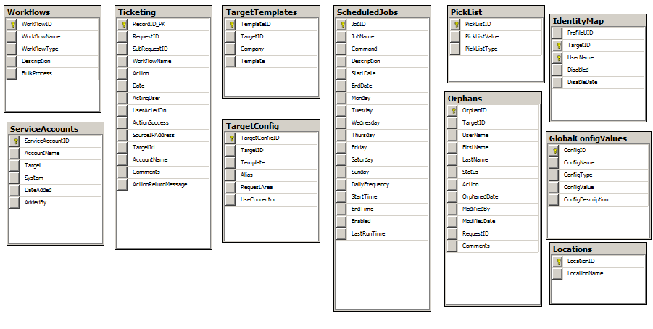
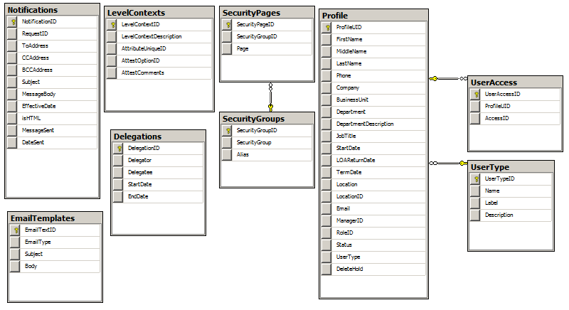
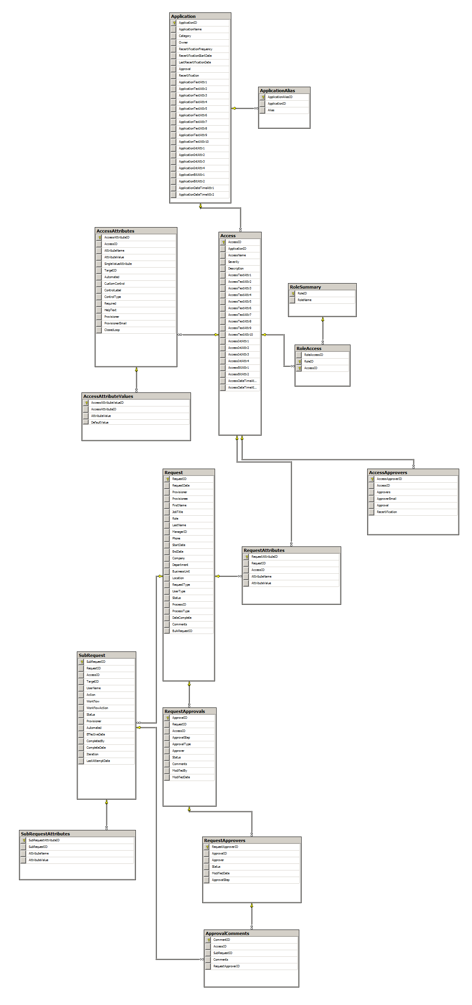

Schema Description
This section will provide a high level overview of the ARM Schema and will highlight the most critical objects.
Identity Objects:
- Profile – This table contain one record for every user in the organization. It contains demographic information pertaining to employees and non-employees
- IdentityMap – This table contains all of the accounts the user has that Courion has insight into and is mapped to the user’s unique identifier.
- UserAccess – This table contains access that a user has at the access level rather than the account level.
Request Objects:
- Request – This table contains all parent requests generated through the Access Request workflow ARM-WF1
- SubRequest – This table contains all access level requests generated through the Access Request workflow ARM-WF1
- RequestApprovals – This table contains the approval steps for each SubRequest, if any. It details the approvers for the request as well as the status of each step
Access Catalog Objects:
- Application – This table contains the definition for all applications in the Access Catalog. This includes Application Name and Category
- Access – This table contains the definition for all access levels in the Access Catalog and which application they relate to
- AccessAttributes – This table contains the relationship between attributes and its corresponding access level
- AccessAttributeValues – For access attributes that contain drop-down lists, this table holds the possible values as well as which value is the default.
- AccessApprovers – This table contains the definition of the approvers for each access level, if any.
Configuration Objects:
- GlobalConfigValues – This table defines many areas of the ARM portal. It includes configurations from fields that are displayed in the pages, to what macros to use to define the behavior of the application.
- PickList – This table defines the various values that can be used in various sections of ARM. This includes: Application Categories, Request Statuses, and Approver Types
- UserTypes – This table defines the user types that are available in ARM-WF1

Database Merging
When ARM is being implemented alongside an existing Courion deployment, the ARM schema is authoritative. In order to merge the ARM schema with the schema of an existing Courion deployment, the following steps need to occur:
- Add missing columns/tables from the original schema to the ARM schema.
- Run the migration SSIS package (provided by Professional Services) to convert existing data types from the existing Courion database into the data types that the ARM Schema expects.
  - This SSIS package will be responsible for moving existing data as well
- Re-point existing Provisioning Workflows and SSIS packages to the new Courion ARM database.
- Rebuild the data model that ARM uses through the Customizations API (delivered by Professional Services).

Data Contracts

FIM

Overview
Courion ARM will direct all provisioning requests for new account creation, account update and scheduled disable actions through to FIM for the following Target Systems:
- Active Directory (All Domains)
- Exchange
- ADAM
- Remedy (Profiles)
Account Creation will be greatly simplified in this solution. All accounts created by FIM will be template or generic accounts with a very limited number of template types. For example, by default an AD account will be created within a default OU, and basic AD group memberships with demographic details stamped onto the Account. Any additional access required by the user will be requested by the users Supervisor through the Access Request process.
The data agreement dictates a direct SQL to SQL relationship to service these requests. Courion will warehouse the following STAGING_FIM table/view and will manage the contents of this table for the benefit of initiating provisioning actions. FIM will perform a delta check against these tables on a regular interval to the following effect:
- If a new row is added, FIM will initiate an account creation action based on rules. FIM will be responsible for updating the Domain, UserName, Email and Response columns once action is completed.
- If a status code changes (enabled to disabled), then FIM will trigger a regular disable action.
- In the event of an attribute change, FIM will take action according to pre-defined business rules.
Courion will also warehouse the STAGING_IdentityMap_FIM, which will be managed by FIM itself. This will become a data feed for the purposes of identityMapping AD Accounts.
Lookup tables will also be contained within the Courion ARM DB to do data conversions. These tables will be made available to FIM on as needed bases to support provisioning actions.

Table/View Schemas

ARM to FIM (STAGING_FIM)
FIM Attribute | Desc | Data Type | Lawson Attr | non-emp Attr | Profile Column
[Inbound to FIM]
firstName |  | nvarchar(50) | First Name | First Name
middleName |  | nvarchar(50)
lastName |  | nvarchar(50) | Last Name | Last Name
employeeID | Employee: LawsonID, non-emp: Courion generated ID | nvarchar(50) | LawsonID | Employee ID
EmployeeStatus | LAWSON STATUS Codes (a1/a2/etc), new codes for non-emp (lookup table) | nvarchar(50) | EmpStatus | (lookup Table)
EmployeeType | emp/non-emp | nvarchar(50) | UserType
Process Level | (used to determine domain) Lawson Attr, non-emp: lookup table | nvarchar(50) [really is int] | ProcessLevel
LocationCode | (used to determine domain) Lawson Code, non-emp lookup table | nvarchar(50) [really is int] | LocationCode
Department | Lawson: pass through, non-emp: pass through | nvarchar(250) | DeptName | Dept Name
Title | demographic data | nvarchar(50) | Position Description | Title
manager | employeeID of Manager from Lawson only, send NULL for non-emp | nvarchar(50) | SupervisorEmployeeNumber | <NULL>
IT Manager | identifies a manager in IT, non-employees are always FALSE | Bool | ?? | <FALSE>
isNationalEmployee | (This is used to trigger Exchange mailbox creation) True only for National Employees, non-emps is always False | Bool | ?? | <FALSE>
TerminationDate |  | Datetime | TermDate | TermDate
CourionTerm | Courion specific flag set on "Emergency Term" action | Bool | N/A | N/A | HardTerm
Telephone |  | nvarchar(50)
phone ext |  | nvarchar(50)
UID | Sequential SQL GUID | SQL GUID() | <GENERATED> | <GENERATED> | ProfileUID
[Outbound to Courion]
Domain | value returned by FIM | nvarchar(50) | N/A | N/A | Domain
samAccountName | value returned by FIM | nvarchar(50) | N/A | N/A | AD_Login
Email | value returned by FIM | nvarchar(50) | N/A | N/A | Email
Status from FIM | error/status message from FIM | nvarchar(500)
?checksum? | checksum(domain, samAccountName, email)

ARM to FIM (STAGING_IdentityMap_FIM)
FIM Attribute | Desc | Data Type
UID |  | nvarchar(50)
Domain |  | nvarchar(50)
UserName |  | nvarchar(50)
Status | active/disabled in AD | nvarchar(50)
hasExchange | hasExchange = has Mail Box in specified AD Domain | Bool
isPrimary |  | Bool

SAMPE: Staging Source
UID | Domain | UserName | Status | hasExchange | isPrimary
1234567 | CHI | Jsmith | Active | T | T
1234567 | Abc | Jsmith21 | Disabled | F | F

SAMPLE: IdentityMap Destination
ProfileUID | TargetID | UserName | Disabled
1234567 | CHI | Jsmith | FALSE
1234567 | Exchange-CHI | Jsmith | FALSE
1234567 | Abc | Jsmith21 | TRUE

ARM/FIM Lookup (LOOKUP_ProcessLevel)
Proces Level Code | Process Level Desc
1 | a
2 | b
3 | c
4 | d
… | …

ARM/FIM Lookup (LOOKUP_Location)
Location Code | Location Desc | Address1 | Address2 | …
1 | a
2 | b
3 | c
4 | d
… | …

Future Items

Authentication
With current product functionality, Authentication into the Portal is limited to single AD Domain authentication (CHI). Users without an account on the CHI domain which is also mapped will not be able to log into the ARM Portal.
Future items from this are to include multi-domain authentication into the ARM Portal when it becomes available in subsequent product updates.

Delegations
This is a desired feature by CHI which is not currently available as product functionality. As this becomes available in future updates, the intention is to include this capability into the CHI solution

Emergency Terminations
Ability to change “Business Supervisor”.

